**Primary Prevention of Violence Against Women:**

A Survey of Activities in Australia

Suggested citation:

Australian Women Against Violence Alliance (AWAVA) (2019) Primary Prevention of Violence Against Women: A survey of activities in Australia.

Table of Contents

What is primary prevention of violence against women? 3

What did this survey aim to do? 3

Part 1: A picture of prevention activities across Australia 4

Type of organisation 4

Location 4

Membership of networks 6

Organisational effort, paid staff / volunteers 6

Who are the prevention activities targeted at? 7

Setting 8

Internal and external guidance for prevention work 9

Prevention activities 10

How did activities aim to prevent violence? 10

Duration of the activities 11

Techniques or types of activity 12

Evaluation 13

Part 2: Constraints and enablers for prevention work 14

What influences organisations/groups to do prevention work? 14

Tensions and difficulties in doing prevention work 15

What has most enabled your prevention work? 16

What do you need more of to enable your prevention work? 16

Tools, resources, learning and guidance needed 17

What respondents think about how primary prevention is progressing 18

The AWAVA Violence Prevention Working Group 18

**Australian Women Against Violence Alliance (AWAVA)** is one of the six National Women’s Alliances funded by the Australian Government to bring together women’s organisations and individuals across Australia to share information, identify issues and contribute to solutions. AWAVA’s focus is on responding to and preventing violence against women and their children. AWAVA’s role is to ensure that women’s voices and particularly marginalised women’s voices are heard by government, and to amplify the work of its member organisations and Friends and Supporters. AWAVA’s members include organisations from every State and Territory in Australia, representing domestic and family violence services, sexual assault services, services for women in the sex industry and women’s legal services, as well as organisations representing Aboriginal and Torres Strait Islander women, young women, women educators and other groups. AWAVA's contract manager is the Women's Services Network (WESNET).

## What is primary prevention of violence against women?

Primary prevention is an approach to address the underlying gendered and other intersecting drivers of violence to stop violence before it occurs. Primary prevention of violence against women encompasses activities to build respectful relationships and increase gender equality to reduce and ultimately end violence against women. It also includes activities to counter other forms of discrimination that combine with gender inequality and can contribute to increased severity or prevalence of violence against women experiencing these multiple forms of discrimination.

The concept of primary prevention draws on a public health model which also encompasses early intervention, response and recovery. While women’s organisations have been using community education and systemic change approaches for many decades as part of their work on violence, investment in a public health approach to primary prevention is a relatively new focus for government, and as such involves a fairly small and new workforce. This survey encompassed activities that work within a formalised primary prevention framework, and also activities that practitioners may not consider in these terms but are substantively contributing to ending violence against women by building respectful relationships, gender equality and social justice.

## What did this survey aim to do?

The survey was conducted between December 2018 and February 2019. It was the first attempt to map primary prevention activities across Australia. The survey aimed to create a picture of activities to inform policy, practice and advocacy, and to identify key enablers as well as barriers and challenges to prevention work.

Any organisations, services or activities that work to build respectful relationships and/or increase gender equality were considered to be in scope. This included activities that have the specific purpose of preventing violence against women such as Respectful Relationships programs in schools, but it also included activities to promote gender equality and address intersecting forms of discrimination more broadly.

The survey drew on and adapted the format used in the 2018 project by Ernst and Young and the Victorian Office for Women on mapping primary prevention activity and infrastructure in that state.[1]

Respondents were recruited through public promotion via social media and newsletters, and through the extended networks of AWAVA’s Violence Prevention Working Group.

We received 60 responses to the survey. The majority of responses came from Victoria and New South Wales.

The results do not include all prevention activities, since some people conducting these activities would not have learnt about the survey, or even if they knew of the survey would not have completed it. Further, the results are based on respondents’ own labelling of their work as primary prevention, and therefore give a working picture of how primary prevention activities are understood by organisations and practitioners within the sector. The findings presented in this report should be interpreted with these limitations and factors in mind.

# Part 1: A picture of prevention activities across Australia

## Type of organisation

Most of the organisations who reported doing primary prevention were **community services organisations** (30 - half of all respondents). Of these, most (18) were **women’s/domestic and family violence**/gender-focused services or organisations.

The next most common types were local government (9), health organisations - mainly women’s health services (5) and state government agencies (5).

It appears that the community sector, and in particular women’s and DFV services/organisations, are still undertaking a significant proportion of the primary prevention work. Local government and women’s health services need to be recognised as key contributors, following women’s and DFV services/organisations.

Other types of organisations can play a valuable role in primary prevention too. Work to address the drivers of violence must occur across all types of organisations, and across the range of settings (such as workplaces, schools and sporting organisations) in order to effectively create the whole-of-population cultural change needed to prevent violence.

## Location

Most organisations were based in and operated in **Victoria, followed by NSW**.

The organisations operating nationally were equally likely to have their main offices in NSW or Victoria (5 based in each state, as well as one in Tasmania and one in the ACT).

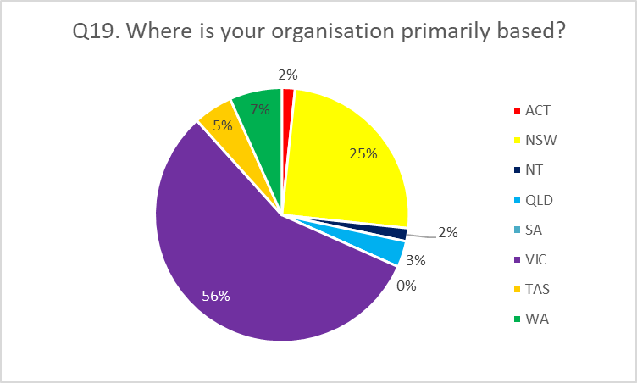

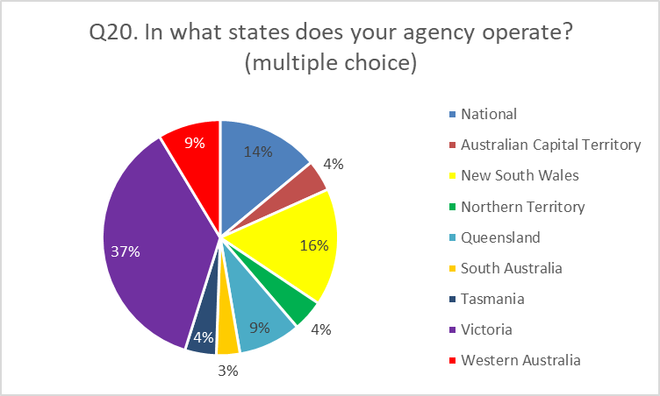

The Victorian investment in responses to the Royal Commission as well as long-running commitment from, and investment in, women’s health services and State government to developing prevention approaches has created a relatively large primary prevention sector in Victoria. Primary prevention understood broadly encompasses a large range of activities and practitioners, but has become more widely understood and named as a result of VicHealth’s early work in developing the first prevention framework and funding much of the first prevention activities in Victoria, as well Our Watch’s location and the influence of the Victorian Royal Commission into Family Violence. It is important to acknowledge that Victoria has invested in primary prevention through women’s health, an approach which differs from other States and Territories.

## Membership of networks

Most organisations doing primary prevention (82%) were involved in some kind of network focused on primary prevention, most of which were local/regional. This echoes the Victorian survey.

**Networks run by women’s health services** (mostly in Victoria) were the most commonly cited networks that prevention initiatives were connected with.

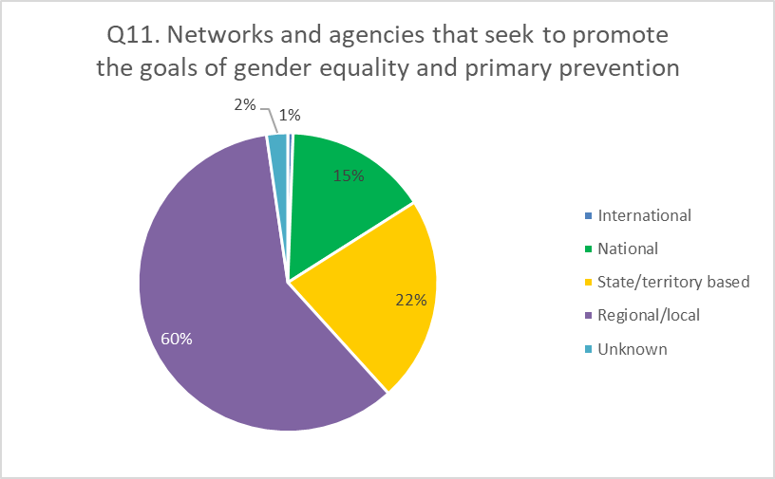

The fact that the survey was distributed through networks may have influenced this finding. It is very likely that other primary prevention initiatives are operating outside of these networks. This finding may also reflect the fact that the majority of survey responses were from organisations based in Victoria, where women’s health services have been funded to coordinate prevention activities for a number of years, particularly at regional/local levels.

## Organisational effort, paid staff / volunteers

The majority of the prevention activities that respondents told us about were **done by paid staff, or by a mix of paid staff and volunteers**. Very few were done by volunteers only.

Fifteen organisations spread mainly across NSW and Victoria had ten or more paid staff dedicating at least part of their time to primary prevention.

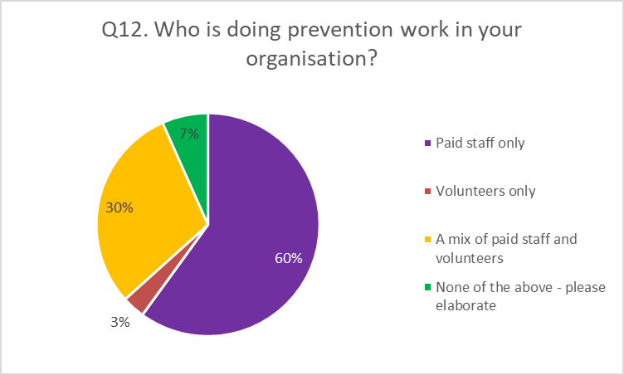

**For most organisations, primary prevention is only part of their work.** Very few respondents reported that the whole of their organisational effort is going towards primary prevention (7). The most common response (from 25 respondents) was that around 10% of organisational effort is going towards primary prevention.

The prevention activities documented by the survey depend on resourcing and capacity within organisations that overall are not solely or even mainly devoted to primary prevention.

The sectors in which we found most prevention activity being done (especially community services, local government and women’s health services) are committing staff and resources to primary prevention. This does not necessarily mean that funding is adequate to support these activities or the goals of primary prevention.

It is possible that these results are influenced by organisations with paid staff having more capacity to fill in the survey, or being more connected to networks through which the survey was distributed.

## Who are the prevention activities targeted at?

Most (40 out of 60 responses) activities **target the whole population**. The next most common target groups were women (34), employees (31), young people aged 13 to 24 (31), people living in rural, remote and regional areas (28), and girls (25).

The groups least reported as being targeted were faith-based communities (10), people in insecure housing (10) and people who are elderly (13). It is acknowledged that these results may reflect the distribution networks available to AWAVA.

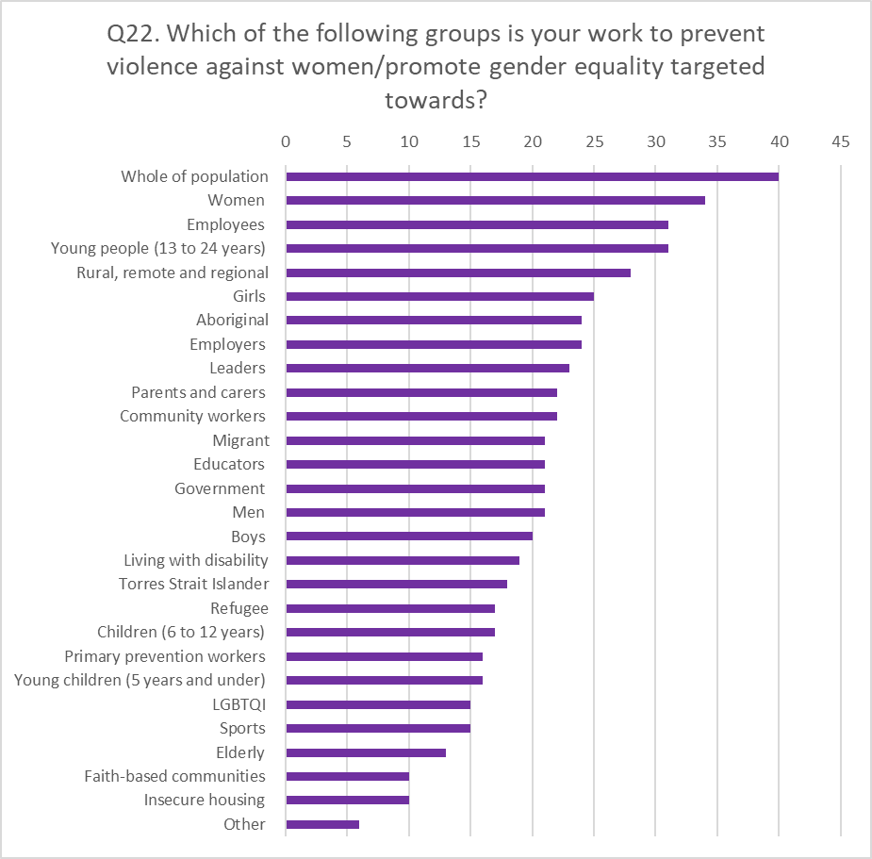

The majority of activities are taking a whole of population focus, which we know is an essential component of primary prevention work. However, there is also a fair amount of work being done with groups who experience intersecting forms of disadvantage and inequality.

## Setting

The **workplace** was by far the most commonly cited setting in which primary prevention work was being undertaken (43 out of 60 responses), followed by **family and community services**-related settings (31), **secondary schools** (28), and **sport and recreation**-related settings (24).

The least commonly reported settings were public transport/infrastructure-related (5), religion/faith-related (6), and entertainment-related (7).

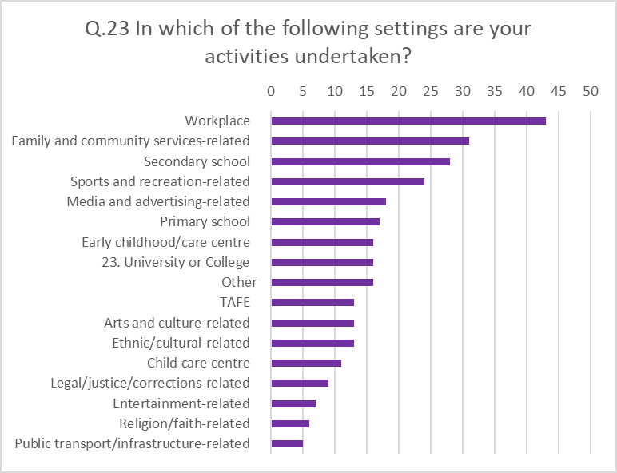

Both the target group and setting responses show that in the education sector, **secondary schools/students are the most likely to be targeted**, more than primary schools/students or child care centres/child-care aged children, and more than universities/tertiary education students. This may indicate a need for more primary prevention activities in the other settings and groups, and advocacy for resourcing to support prevention work in all settings. In particular, it is notable that there are relatively fewer activities related to university and TAFE settings, which is concerning in light of the Change the Course report findings and outcomes. Other settings with limited prevention activities include arts and culture; entertainment; faith-based contexts; public spaces, transport and infrastructure; and legal, justice and corrections settings.

## Internal and external guidance for prevention work

The large **majority (90%) of respondents reported having internal documentation** (such as strategic plans or policy documents) that outline theories of change and/or promoted gender equality for the prevention of violence against women.

Respondents also told us about their external sources of guidance, the most common being the National Plan to Reduce Violence Against Women and their Children (51%) and Our Watch resources (42%). Only 7% reported using no external sources of guidance.

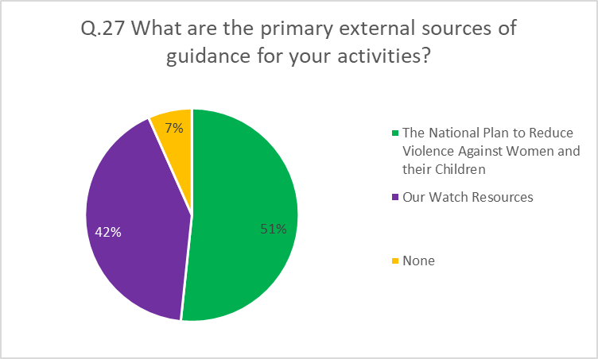

Of the Our Watch resources cited, [Change the Story: a shared framework for the primary prevention of violence against women and their children](https://www.ourwatch.org.au/getmedia/0aa0109b-6b03-43f2-85fe-a9f5ec92ae4e/Change-the-story-framework-prevent-violence-women-children-AA-new.pdf.aspx) was the most commonly used resource, followed by [Putting the prevention of violence against women into practice: How to Change the story](https://www.ourwatch.org.au/getmedia/a8d9dc3d-2291-48a6-82f8-68f1a955ce24/Putting-prevention-into-practice-AA-web.pdf.aspx); [Counting on Change: A Guide to Prevention Monitoring](https://ourwatch.sharepoint.com/PracLeadership/Projects/AWAVA%20Prevention%20Group/Counting%20on%20Change:%20A%20Guide%20to%20Prevention%20Monitoring); and [Changing the Picture: a national resource to support the prevention of violence against Aboriginal and Torres Strait Islander women and their children](https://www.ourwatch.org.au/getmedia/ab55d7a6-8c07-45ac-a80f-dbb9e593cbf6/Changing-the-picture-AA-3.pdf.aspx). Widespread citation of Our Watch resources shows that there is awareness of evidence-based resources and that they are easily accessible. It would also suggest there is widespread support for a shared and consistent understanding of and approach to preventing violence against women nationally.

Some respondents kindly provided links to their internal and external documentation with a view to sharing with other practitioners. AWAVA is pursuing opportunities to create platforms for this sharing.

## Prevention activities

Understanding that individual organisations or groups may do more than one prevention activity, we asked about these activities separately. **A total of 209 activities were reported by 58 organisations/groups.**

## How did activities aim to prevent violence?

We asked what action (or step) towards preventing violence against women the activity targeted. The most common actions were “**Challenge gender stereotypes and roles**”, and “**Promote positive, equal and respectful relationships**.”

The least commonly reported action was “Address other forms of discrimination and oppression that intersect with the gendered drivers.”

|  |
| --- |
|  |

Chart legend:

|  |  |  |
| --- | --- | --- |
| Action 1 | 94 | Promote women’s independence and decision-making in public life and relationships |
| Action 2 | 125 | Challenge the condoning (excusing, justifying, trivialising, minimising) of violence against women |
| Action 3 | 133 | Challenge gender stereotypes and roles |
| Action 4 | 134 | Promote positive, equal and respectful relationships between and among women and men/girls and boys |
| Action 5 | 75 | Address other forms of discrimination and oppression that intersect with the gendered drivers |
| Action 6 | 29 | Other - Write In |

These findings are in line with the emphasis over the last decade or so on challenging the condoning of violence against women, challenging gender stereotypes and promoting respectful relationships. The importance of taking an intersectional approach is a relatively newer approach in prevention, and will need further work in the future, in order to prevent violence against all women.

## Duration of the activities

While nearly a quarter (23%) of reported activities were short term or one-off events, the largest proportion (39%) were **more than two years in duration**.

The majority of these long-term / ongoing activities were in Victoria, again reflecting the earlier significant investment in primary prevention in that state.

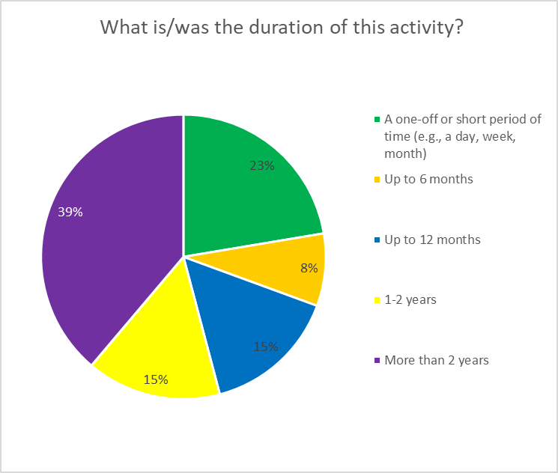

The commitment by primary prevention practitioners to long term programs and change is heartening, especially in light of structural challenges such as limited-term funding and shorter project cycles. Prevention efforts need to be long-term in order to be effective, and the findings here indicate that many organisations are committing over the long term.

## Techniques or types of activity

The most common techniques were **training/workshops** and developing **tools and resources**.

Least common were online forum/discussion and media/advertising campaign.

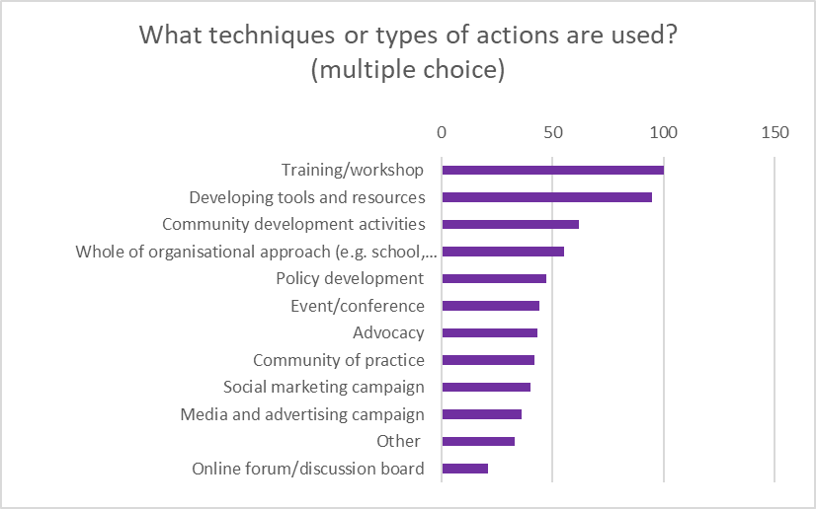

Although development and delivery of training and resources is a critical element of prevention activities and in increasing the awareness, skills and confidence of people to prevent violence against women, training can often be short term and it is important this is supported by a range of other activities which are longer term and complement the learning.

## Evaluation

**Over 90% of activities were being evaluated**, while only 18 activities had no formal measurement of outcomes in place.

The most common forms of evaluation used were **participant feedback** and **reporting on outcomes**.

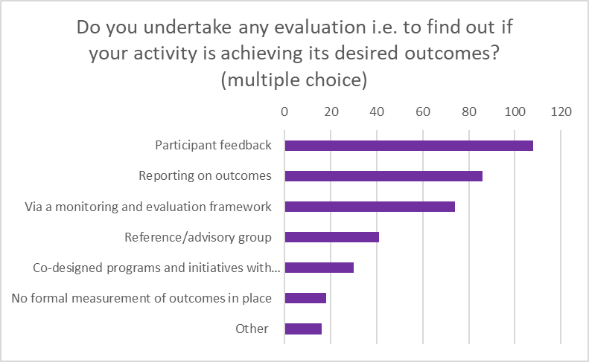

Considered together with the responses about constraints and needs for different enablers (below), these findings show that additional resourcing for monitoring and evaluation are needed to establish and develop the evidence base for prevention. While participant feedback and reporting can be useful sources of information, they are not equivalent to a well-developed monitoring and evaluation framework. Monitoring and evaluation requires dedicated resources, which can be difficult to achieve in settings where funding is limited.

# Part 2: Constraints and enablers for prevention work

## What influences organisations/groups to do prevention work?

In most cases organisations/groups are doing prevention **because it aligns with their core work**.

Other important influences are receiving funding, internal commitment from leadership, and participation in communities of practice.

*As an organisation committed to gender equality, we understand that violence against women is intrinsically linked to gender inequality. Our aim is to create population-level change, as well as supporting individuals to make change. As such, we direct our work towards prevention as a key area of program and service delivery*

## Tensions and difficulties in doing prevention work

**Limited funding** is the key difficulty noted, affecting 80% of respondents. Given the majority of respondents are community services organisations, it is likely the problem of limited funding is a broader one.

Another key difficulty is **dealing with resistance and backlash**. This highlights that primary prevention is an area that is potentially personally challenging and exhausting for workers.

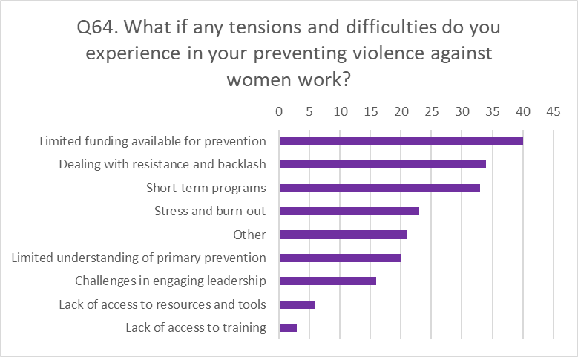

Many of the ‘other’ responses also highlighted problems with funding, capacity and competition for resources.

*Short-term funding is the most significant constraint. Primary prevention aims to achieve long-term social and cultural change and requires sustained funding. Short-term grants lead to stress, loss of expert staff and loss of momentum, and mean we need to spend significant time applying for funding rather than getting on with the work*

*No funding at all. Attitude from Government that refuges are response services and don't do prevention.*

These responses highlight the tension between evidence about what is required to successfully achieve primary prevention on one hand (e.g. long-term, well-resourced) and, on the other, the current reality of implementing prevention activities (e.g. short-term or non-existent funding).

## What has most enabled your prevention work?

**Dedicated, skilled workers** were cited by over 80% of respondents as the factor most enabling prevention work. This finding aligns with Our Watch’s Counting on Change: a guide to monitoring, which recognises that a skilled workforce is a key infrastructure area that will enable effective primary prevention at a population level. It also indicates the importance of funding for specialised services and workers.

Other important factors were **internal commitment** from senior leadership and participation in **communities of practice**.

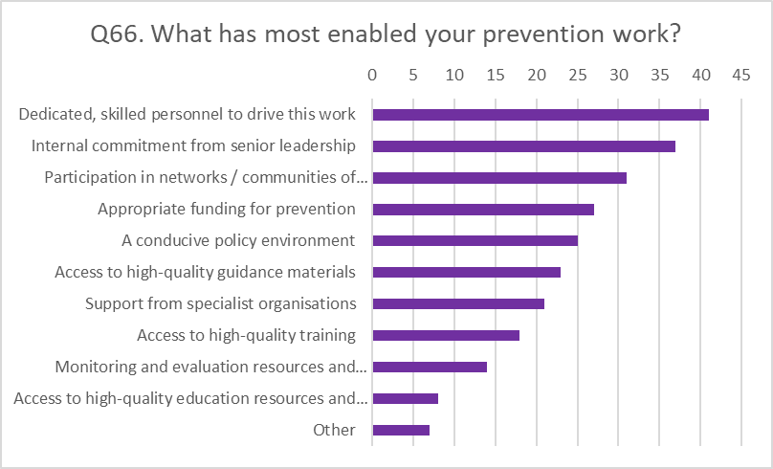

## What do you need more of to enable your prevention work?

84% of respondents said they need **more appropriate funding** to enable their prevention work, while many also cited dedicated, skilled personnel as needed.

A significant proportion (58%) said they needed resources and support in relation to **monitoring and evaluation,** which aligns with the finding that many prevention activities are not fully evaluated through a formal framework.

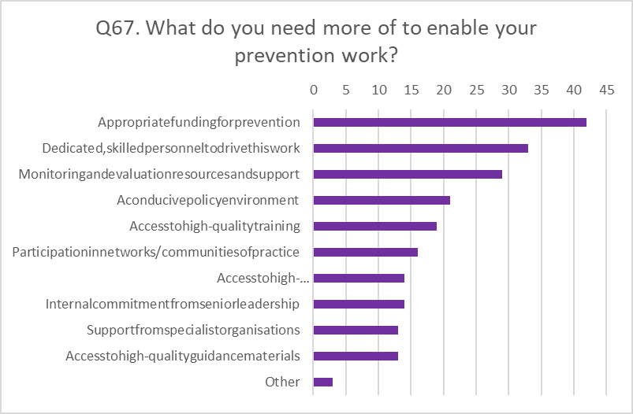

## Tools, resources, learning and guidance needed

We asked a number of questions about what practical measures would support respondents in their work.

Many respondents cited the need for training, support and resources for conducting **evaluation and monitoring**. This included comments about being sufficiently funded and resourced to enable evaluation of organisational programs and resources; having evaluation tools tailored to diverse communities; ensuring that evaluation is long-term and embedded in programs and projects; having dedicated staff and developing evaluation strategies that are specific to regional and rural areas.

As mentioned above, having more support and resources for monitoring and evaluation will help to build an evidence base for primary prevention in Australia.

Many respondents reported needing more tools for **conducting prevention work with diverse communities and embedding an intersectional approach**.

**Limited and uneven access to training** was highlighted in terms of location, funding and organisational capacity.

Respondents also said they needed **communities of practice**, **information sharing** and tools and techniques to **deal with resistance and backlash**. A range of responses to support workers to effectively deal with resistance and backlash are needed, in order to continue to enable them to progress the primary prevention work. In addition, access to external supervision and the development of resources and networks is needed to support workers.

## What respondents think about how primary prevention is progressing

In answer to open ended questions, respondents emphasised issues of funding, resourcing and staffing of primary prevention work:

* + There are issues with the **levels of funding**. It was noted that there needs to be long-term and ongoing funding for primary prevention work. Currently, resourcing is limited. It was noted that funding is not consistent across States and Territories. It was also noted that in some cases funding is given to generalist services that are not doing primary prevention work according to the sector standards. This is a significant constraint given the importance of a skilled and dedicated workforce.
  + There are also indicated issues related to **staffing**. This included the need for a specialist workforce, service standards, workforce development and sufficient level of funding to provide competitive wages and long-term contracts.

Respondents thought it was important to have **strong, consistent approaches** to primary prevention:

* + Responses included a need for nationally-consistent approaches in primary prevention work, a change of attitude from regarding primary prevention as something that can be achieved through one-off activities or training events, to an approach that is mainstreamed and requires ongoing resourcing and activities.
  + Respondents indicated the need to legislate gender equality and introduce comprehensive education on gender equity in schools.
  + Some responses addressed the diversity of groups and approaches and indicated a need for an intersectional approach to primary prevention, better engagement with communities, activities specific to Aboriginal and Torres Strait Islander people and faith communities.

## The AWAVA Violence Prevention Working Group

The survey was conducted by AWAVA as a project of its Violence Prevention Working Group. Working Group members contributed to the design, distribution and analysis of the survey. Members' contributions are gratefully acknowledged. The Working Group members (as at 19 September 2019) are:

Aloma Fennell – National Older Women’s Network

Angela Walsh – Create Space Consultancy

Anna Hush – fEMPOWER

Ashlee Donohue – consultant

Cat Gander and Jozefa Sobski – Women’s Electoral Lobby

Claire Tatyzo and Jemma Taylor – YWCA Australia

Genevieve Dugard – Project O, Big hART

Hayley Foster – Women’s Safety NSW

Jane Torney – Our Watch

Jill Maxwell – Sexual Assault Supoprt Service, Tasmania

Julie Oberin – WESNET – The Women’s Services Network

Karen Parter – National Aboriginal and Torres Strait Islander Women’s Alliance

Keli McDonald and Leonie Noble – National Rural Women’s Coalition

Laura Maclean – White Ribbon Australia

Maria Delaney – Association of Women Educators

Monique Dam – Domestic Violence NSW

Maria Dimopoulos and Sana Ashraf – Harmony Alliance

Romy Listo – Equality Rights Alliance

Terese Edwards – National Council for Single Mothers and their Children and economicSecurity4Women

1. <https://w.www.vic.gov.au/system/user_files/Documents/fv/Primary_prevention_activity_and_infrastructure_in_Victoria_-_Office_for_Women_Summary_report.pdf>