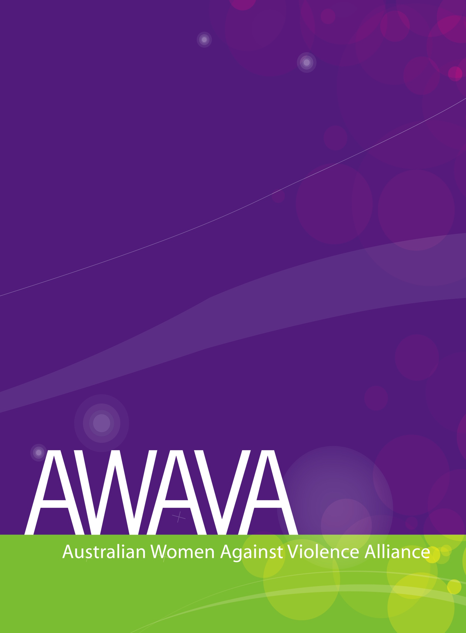**2019-2020**

**Federal Budget**

Budget measures to address violence against women and their children



**Table of Contents**

Acronyms/Glossary 2

Budget overview 3

Measures across portfolios 5

Fourth Action Plan (2019-2022) to reduce violence against women and their children 5

Women’s Economic Security Package 7

Women’s Safety Package 8

Other measures related to addressing violence against women 8

Attorney General’s Portfolio 8

Measures directly related to addressing violence against women and their children 9

Measures indirectly related to addressing violence against women and their children 13

Department of Social Services Portfolio 14

Measures directly related to addressing violence against women and their children 14

Measures indirectly related to addressing violence against women and their children 14

Prime Minister and Cabinet 15

Measures directly related to addressing violence against women and their children 15

Measures indirectly related to addressing violence against women and their children 15

Department of Communications and Arts Portfolio 16

Measures directly related to addressing violence against women and their children 16

Measures indirectly related to addressing violence against women and their children 16

# Acronyms/Glossary

AGD Attorney-General’s Department

DSS Department of Social Services

FASS Family Advocacy and Support Services

Fourth Action Plan Fourth Action Plan of the National Plan to Reduce Violence Against   
 Women and their Children

National Plan National Plan to Reduce Violence Against Women and their Children  
 2010-2022

OIWS Package Our Investment in Women’s Safety Package

VAW Violence against women

# Budget overview

The 2019-2020 Federal Budget has restated its previously made commitment to fund prevention and responses to domestic, family and sexual violence. Announced at the beginning of March 2019, the $328 million as the Our Investment in Women’s Safety (OIWS) package constitutes the Commonwealth contribution towards the Fourth Action Plan of the National Plan to Reduce Violence Against Women and their Children. This package will be spread across 8 portfolios and comprise of a broad range of measures.

The 2019-2020 Federal budget remains a document that is complicated to read due to its lack of transparency. It is hard if not impossible to track measures in relation to responding to violence against women (VAW). For instance, in addition to the announced OIWS Package, there are other measures aimed at funding responses to VAW. This includes either ongoing funding to particular Departments (eg. Grants within DSS) or other measures that fall outside the National Plan (eg. Legal assistance). Often they are hidden under names such as ‘special accounts’ or subsumed within the Departmental funding in the following years after the announcements are made. This makes it difficult to measure and track the commitment to reduce VAW across the whole of government, which appears to be greater than publicly made announcements. We need a comprehensive budget statement tracking spending across all portfolios in a way that enables year-on-year comparisons and states clearly where spending is going.

Overall, AWAVA [has welcomed](https://awava.org.au/2019/03/06/media-release/awava-response-to-our-investment-in-womens-safety-package?doing_wp_cron=1554259688.7029290199279785156250) the OIWS package, in particular the investment into primary prevention. Yet, [we reiterate recommendations](https://awava.org.au/2018/10/08/uncategorized/position-paper-fourth-action-plan?doing_wp_cron=1554265010.0306921005249023437500) that the efforts to address violence against women need to be holistic in their nature. An intersectional approach needs to be embedded within the forthcoming Fourth Action Plan as well as the Fourth Action Plan needs to address different forms violence can take, respond to the increasing service demand and prioritise the unique role special women’s services are playing in reducing violence against women.

We welcome the commitment to address technology-facilitated and financial abuse, however other forms of violence against women such as reproductive coercion, dowry abuse, forced sterilization of women with disability remained unaddressed. Similarly, there must be a more nuanced engagement with the diversity of women in Australia. AWAVA’s position paper on the development of the Fourth Action Plan outlines how to embed intersectionality within prevention and response to VAW in a greater detail.[1]

While this has been the biggest investment to date from the Commonwealth in measures to respond to violence against women in Australia, the Budget provides little if any funding directly to providing specialist women’s domestic and family violence services on the ground, setting aside the $10 million to Specialised Family Violence Services delivered through family and relationship centres, the DV units and the ongoing funding to the National Plan Partners such as 1800RESPECT. The prevalence of domestic and family violence remains high, and there has been an increase in women’s experiences of sexual violence.[2] Domestic and family violence remains the single largest cause of homelessness for women. With more work done in prevention, more women are seeking services, as predicted by Our Watch’s Counting on Change guide to prevention monitoring.[3] The funding to the specialist women’s services must meet the increasing demand.

There are also several broader changes needed in the areas of migration and social security, including abolishing the punitive ParentsNext program, increasing the rate of Newstart payments, and addressing the critical need for essential services to be provided to women on temporary visas who are facing domestic and family violence.[4]

|  |  |  |  |  |  |  |
| --- | --- | --- | --- | --- | --- | --- |
| **NEW** | | | |  | **GAPS** | |
| Commonwealth contribution to the **Fourth Action Plan** of the National Plan to Reduce Violence Against Women and their Children (new but expected) | | | | Adequate funding to **meet the rising demand for specialist women’s services** | |
| **Royal Commission into Violence, Abuse, Neglect and Exploitation of People with Disability** | | | | Adequate indexation for **National Women’s Alliances** | |
| **Single National Mechanism for Commonwealth Legal Assistance** | | Expansion of **Family Advocacy and Support Services** | | Adequate funding to **meet the rising demand for specialist homelessness services** | |
| Additional Funding for the **eSafety Commissioner** | | **Elder Abuse** package | | Funding for the implementation of the **ALRC family law review** | |
| Focus on keeping **perpetrators accountable** | Adequate funding to **Family Violence Prevention Legal Services** |
|  | | |  | |  | |
| **ONGOING** | | | |  | **CONCERNS** | |
| **Baseline National Plan funding** (DSS) | | | | **Funding to family violence service that may not have gender expertise** | |
| **Family law system funding** (AGD) | | | | Extension of **Cashless debit cards** trial | |
| **Legal Assistance Funding** (AGD) | Funding for **National Housing and Homelessness Agreement** | | | **Aboriginal and Torres Strait Islander Legal Services** **to be subsumed** under the Single National Mechanism for Commonwealth Legal Assistance | |

# Measures across portfolios

## Fourth Action Plan (2019-2022) to reduce violence against women and their children

*BUDGET PAPER 2, page 160*

The main budget measure to address violence against women is a previously announced $328 million package that constitutes a contribution of the Commonwealth towards the Fourth Action Plan. This budget measure has also been spread across eight portfolios and signals a whole of government approach to ending violence against women and their children.

Below is a detailed breakdown of the funding measures:

1. **Funding for the National Plan partners**

$64.0 million in additional funding over two years to ensure that **1800RESPECT** is able to meet forecast increases in demand, update its online services and increase accessibility for vulnerable cohorts. This funding is until 2021. It is expected that 575000 service contacts will be made.

$26 million to continue **DV Alert** training program. DV Alert will train a further 18500 workers.

$7.6 million to further research and developing evidence base through funding **ANROWS** and Australian Institute of Health and Welfare. This includes further research about the experiences of violence against Aboriginal and Torres Strait Islander women, women from culturally and linguistically diverse backgrounds and women with disability.

$3.4 million to **Our Watch** to continue The Line and $0.357 for the evaluation of Our Watch as funding is due to finish in 2022.

These measures are to be administered by DSS.

1. **Safe Places funding**

$75.4 million to provide emergency accommodation for women and children escaping domestic and family violence and to continue the Keeping Women Safe in their Homes program. These measures are administered by DSS.

This includes $60 million to build new emergency accommodation (capital funding) and $18 million for Keeping Women Safe in their Homes Program. DSS’s modelling assumes that the $60 million in capital funding will need to be matched by another $60 million investment from philanthropists, state and territory and local governments. Applicants will need to have this matching funding secured upon application. AWAVA expressed our concerns in this regard, as this may create additional barriers for smaller organisations to apply. AWAVA has also participated in the consultations held by DSS and reiterated our position that the eligibility criteria need to include gender expertise and specialisation in provision of services to victims/survivors of violence. You can find our media release in response to this announcement [here](https://awava.org.au/2019/02/11/media-release/awava-statement-78-million?doing_wp_cron=1554854466.8224658966064453125000).

1. **Primary prevention funding**

$68.3 million in prevention activities that includes:

* + Establishment of Australia’s first prevention hub;
  + $25.4 million for a range of community programs, information campaigns, resources, and awareness-raising initiatives focused on addressing the social behaviours and attitudes that lead to violence against women and children.
  + $12.1 million will fund prevention programs for vulnerable or at risk groups, including Aboriginal and Torres Strait Islander and culturally and linguistically diverse communities.
  + $16.7 million to continue the national Stop it at the Start campaign. To date, the campaign has been delivered in partnership with states and territories contributing matched funding. The Commonwealth looks forward to state and territory governments’ continued investment in this flagship national prevention initiative.

This measure also includes funding to Our Watch stated above in the National Plan Partners’ section.

Other funding included here is:

* + $2.0 million for the Office for Women to support the development of strategies for the prevention of financial abuse.
  + $2.8 million to encourage respectful relationships and support student safety and wellbeing under the Respect Matters initiative. This measure is to be administered by the Department of Education and Training.

1. **Support and prevention strategies for Aboriginal and Torres Strait Islander communities**

$35.0 million to address the specific needs of Aboriginal and Torres Strait Islander people affected by violence, including providing greater support for Indigenous women and children in remote areas and supporting practical intervention programs to work with Indigenous young people and adults at risk of experiencing or committing family violence.

AWAVA supports the concerns of Family Violence Prevention Legal Service that there was no commitment made for their funding beyond 2020 as well as no CPI increase accounted for, or measures to expand FVPLS services beyond their current geographic reach.[5]

1. **Other measures**

We note that the OIWS Package lists other funding measure under the heading of *“Improving frontline services”* with a total investment of$82.2 million. However, the listed measure include a variety of activities not necessarily related to the direct service provision. Below are some of the publicly listed measures.

$7.5 million to expand the *Recognise, Respond, Refer* pilot program, which includes referral pathways for people at risk of domestic and family violence and the delivery of training to general practice staff to recognise the signs of domestic and family violence. This measure is to be administered by the Department of Health.

Improving service delivery for people affected by domestic and family violence with the Department of Human Services to provide streamlined services from within its existing resources.

$11.0 million to improve collaboration and information sharing between the Federal Family Law system and state family violence and child protection agencies to help prevent instances where courts are not advised of family violence risks documented in state systems. This measure is to be administered by the Attorney General’s Department.

$2.1 million to provide national training for the primary care workforce to improve the family violence response capabilities of medical staff.

$4.0 million for the Australian Communications Media Authority to identify, report and support victims of technology facilitated abuse in high-risk Aboriginal and Torres Strait Islander communities and women who have intellectual disabilities to help protect themselves online.

$13.4 million for a range of domestic and family violence support services to assist vulnerable women. It is not clear what is included within this figure. This figure does not match any other measures from the OIWS Package.

$2.6 million to develop new national standards for sexual assault responses including victim and perpetrator programs, and a framework for reporting against the standards.

$3.8 million will deliver critical support for identified victims of human trafficking, slavery and slavery-like practices, including forced labour and forced marriage under the Support for Trafficked People Program.

$10 million to deliver Specialised Family Violence Services in up to 16 additional locations. You can find our media release in response to this announcement [here](https://awava.org.au/2019/04/15/blog/10million-for-specialised-fvservices-why-are-womens-safety-advocates-so-concerned).

More details on the package can also be found [here](https://www.dss.gov.au/sites/default/files/documents/03_2019/our-investment-womens-safety-5-march-2019.pdf).

## Women’s Economic Security Package

The Women’s Economic Security Statement announced in November 2018[6] counts towards the Budget measures to achieve women’s economic security. The statement provides $119.2 million over four years. Measures in relation to domestic and family violence include $35.6 million to support women’s economic independence:

* + providing Specialist Domestic Violence Units and Health Justice Partnerships, including for financial support services;
  + extending early release of superannuation for victims of domestic and family violence;[7]
  + expanding the No Interest Loan Scheme run by Good Shepherd Microfinance to women experiencing family and domestic violence;
  + funding legal assistance to ensure victims of family violence are protected from direct cross-examination by their perpetrators in family law matters;
  + improving the visibility of superannuation assets in family law proceedings;
  + providing family law property mediation;
  + establishing a new Small Claims Property pilots program.

## Women’s Safety Package

### Technology Trials

This is a previously announced measure under the Women’s Safety Package that is administered by the Department of Social Services and the eSafety Commissioner. The funding is available until 2020.

This program supports a series of trials to test new technologies or innovative uses of existing technologies to improve the safety of women and children affected by family and domestic violence.

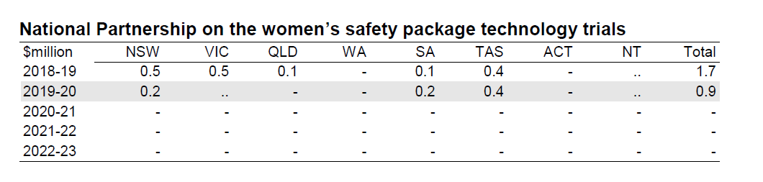

*Budget paper 3 2019-2020, p. 40*

The Budget does not provide funding to continue all programs established under the Women’s Safety Package. This lapse in funding includes the Safer Technology for Women program delivered by WESNET, despite the fact that this program was positively evaluated by an external assessor and the evaluation found that frontline workers in domestic and family violence services want more face-to-face and longer training to support their clients experiencing technology-facilitated abuse.

## Other measures related to addressing violence against women

### Department of Veterans’ Affairs: Partner Service Pensions — eligibility alignment

The Government will provide $6.2 million over four years from 2019-20 (and $1.4 million per year ongoing) to ensure equal treatment of former spouses and former de-facto partners of veterans concerning access to the partner service pension when they separate from their veteran partner.

Both former spouses and former de-facto partners of veterans will be able to continue to receive the partner service pension after their relationship with their veteran partner has ended, including as a result of family or domestic violence.[8]

### Prioritising Mental Health — caring for our community

The Government will provide $229.9 million over seven years from 2018-19 (including $80.5 million beyond 2022-23) to improve mental health services within the community by strengthening social networks and peer groups, supporting social inclusion and increasing treatment options.[9]

One of the funding allocations will be given to the Ester Foundation in the amount of $4.0 million over seven years from 2018-19 for young women’s residential health, development and leadership program to provide counselling to assist with issues such as domestic violence, substance abuse, mental health and self-harm.

# Attorney General’s Portfolio

Attorney General’s Department will be administering several measures related to addressing violence against women. This includes some of the measures announced in the Fourth Action Plan (measure to improve collaboration and information sharing between the Federal Family Law system and state family violence and child protection agencies[10]) as well as other measures in the access to justice area.

Funding described below includes funding announced as a part of the Budget 2019 – 2020 as well as the Budget 2018-2019 - Mid-Year Economic and Fiscal Outlook.

## Measures directly related to addressing violence against women and their children

### Family Advocacy and Support Services

#### General service funding

The Family Advocacy and Support Service (FASS) program has been funded under the Third Action Plan of the National Plan to Reduce Violence Against Women and their Children to provide a holistic service (a duty lawyer and a social worker) for people affected by family violence to navigate the family law system. The Australian Government provided $18.5 million from 2016 to 2019.

The FASS operates in 14 family law court registries and two local court registries in the Northern Territory, 13 of which are regional locations.[11]

Following the FASS’ positive evaluation, as part of the Budget 2018-2019 - Mid-Year Economic and Fiscal Outlook, the Government committed to provide an additional $22.6 million to extend the existing FASS from 1 July 2019 to 30 June 2022.

AWAVA has previously called for the expansion of FASS. We welcome this measure.

#### Dedicated Men’s Support Workers

This is additional funding towards Family Advocacy and Support Services to employ dedicated men’s social support workers in Family Advocacy and Support Services locations to work with male victims and alleged perpetrators of family violence involved in family law matters.

The total investment amounts to $7.8 million over three years from 2019-20. This measure builds on the 2018-19 MYEFO measure titled Family Advocacy and Support Services and Legally Assisted and Culturally Appropriate Dispute Resolution — extension of services.[12]

We welcome this measure. AWAVA sought clarification in regard to the terminology of ‘alleged perpetrators’ and were told that it was meant to encompass both alleged and convicted perpetrators involved in family law matters.[13]

### Funding under the Women’s Economic Security Package administered by the AGD

As part of the package, there is new funding in the amount of $98.4 million for family law services and initiatives to support women and their families to recover financially after separation.[14]

The Package includes:[15]

* $50.4 million in new funding for family law property mediation.
  + $13.0 million each year will be provided to the 65 Family and Relationship Centres across Australia on an ongoing basis to provide mediation services to help families to reach agreements about splitting their property after separation without having to go to court. This funding will be available from 1 July 2019;
  + $10.3 million will be provided for Legal Aid Commissions in each state and territory to conduct a two year trial of lawyer-assisted mediation for families with a property pool of up to $500,000 (excluding debt). The trial will run from January 2020-December 2021;
* $5.9 million in additional new funding for the federal family courts to conduct a two year pilot of simpler and faster court processes for dividing small claim property disputes between separating couples. The pilot will run at four locations across the country from January 2020 to December 2021;
* $3.3 million in new funding for the Australian Taxation Office, as part of a joint measure with the Attorney-General’s Department, to develop an electronic system to allow superannuation information to be provided directly to the family law courts in family law disputes. This will provide the courts with a more timely, accurate and reliable source of information about superannuation assets to inform property settlements;
* $31.8 million over three years (ongoing) to existing Commonwealth-funded specialist Domestic Violence Units and Health Justice Partnerships[16] to continue existing services and expand services to include the provision of financial support services such as financial advice, counselling and literacy.
* ongoing funding, initially $7.0 million over three years, to establish the new Family Violence and Cross-Examination of Parties Scheme. Under the Scheme, Legal Aid Commissions in each state and territory will be funded to provide legal representation to all self-represented parties subject to the ban on direct cross-examination in the Family Law Act 1975.

### Legally Assisted and Culturally Appropriate Dispute Resolution Pilots

This measure builds on the previous funding under the Third Action Plain in the amount of $6.2 million to fund Family Relationship Centres to pilot enhanced models of legally assisted and culturally-appropriate family dispute resolution services for Indigenous and culturally and linguistically diverse families who have experienced family violence.

In 2018-2019 further $2.475 million were provided to extend the operation and evaluation of the pilot until 30 June 2020.

### Single National Mechanism for Commonwealth Legal Assistance

This is a new measure announced in the Budget aimed to subsume under one funding scheme the funding for Legal Aid Commissions, Community Legal Services and Aboriginal and Torres Strait Islander Legal Services.

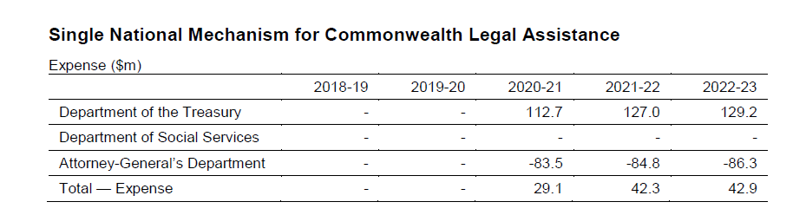

*Budget paper 2, page 55.*

The total investment amounts to $1.2 billion over three years from 2020-21. It is stated that the national mechanism will commence on 1 July 2020 and will allow for a more collaborative, innovative and effective legal assistance sector in order to address legal needs for the most vulnerable Australians.

We welcome this investment as the current National Partnership Agreement on Legal Assistance was due to run out in 2020. The current funding levels are as follows:

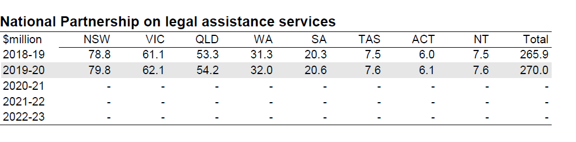

*Budget paper 3.*

We believe that the access to free legal assistance for people living in disadvantaged situations must be an ongoing funding commitment.

However, we share the concerns of the legal sector in relation to this budget measure. Firstly, this funding does not reflect the required investment as called for the Productivity Commission and the Law Council of Australia. In the final report of The Justice Project the Law Council of Australia has recommended to invest a minimum of $390 million per annum in community legal services. We also note that the Productivity Commission recommended an additional $200 million investment to community legal centres. Secondly, abolition of a separate agreement for Aboriginal and Torres Strait Islander Legal Service undermines the commitment to self-determination.[17]

### Additional legal assistance funding

The Government will provide an additional $30.5 million over three yearsfor legal assistance services for those experiencing family violence, older Australians, people with disability, Australians with mental health issues, Indigenous Australians and those living in rural and remote areas.[18]

### Family Law Information Sharing

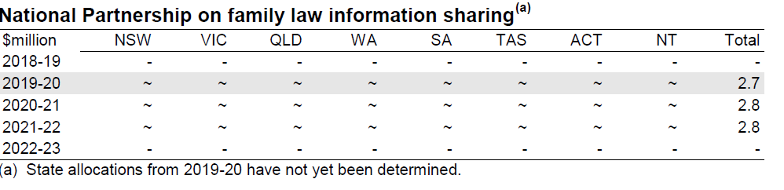

*Budget paper 3.*

The Australian Government will support the placement of state family safety officials (such as child protection or policing officials) in the family law courts across Australia. These co-located officials will facilitate information sharing between the family law, child protection and family violence legal systems. They will also foster a more coordinated response to safety issues, to promote the safety and wellbeing of families and children.

### Royal Commission into Violence, Abuse, Neglect and Exploitation of People with Disability

The funding of $528 million over five years to support the work of the Royal Commission into Violence, Abuse, Neglect and Exploitation of People with Disability will be administered by the Attorney General’s Department ($379.1 million over five years) and the Department of Social Services, the National Disability Insurance Agency and the National Disability Insurance Scheme Quality and Safeguards Commission ($148.8 million over three years).

This is a long sought commitment which is welcomed. As stated in [our submission](https://awava.org.au/2018/09/03/submissions/submission-to-the-consultation-on-the-development-of-the-national-plan-on-elder-abuse?doing_wp_cron=1554865888.3336880207061767578125) in response to the consultation on the terms of reference, the Royal Commission must embed gender and intersectionality lenses in its terms of reference as well as ensure the centrality of the lived experiences.

### Family Law Courts – improving risk identification and management

This measure was announced in the 2017-18 budget to employ additional family consultants. The funding is ongoing and estimated until 2021. No funding increase has been allocated. The funding is administered by AGD ($0.4 million) and the Federal Court of Australia ($5.2 million).

### Funding to the Federal Court of Australia, Family Court of Australia and Federal Circuit Court of Australia

|  |  |  |  |  |  |  |
| --- | --- | --- | --- | --- | --- | --- |
|  | Millions | 2019-2020 | 2020-2021 | 2021-2022 | 2022-2023 |  |
| Federal Court of Australia | **B. 2018-19** | 85.628 | 85.927 | 86.182 |  | **⇑** |
| **B. 2019-20** | 87.365 | 87.671 | 88.326 | 87.789 |
| Family Court of Australia | **B. 2018-19** | 45.092 | 45.199 | 45.291 |  | **⇓** |
| **B.2019-20** | 41.383 | 41.479 | 41.578 | 41.683 |
| Federal Circuit Court of Australia | **B. 2018-19** | 95.066 | 95.490 | 95.860 |  | **⇓** |
| **B.2019-20** | 66.262 | 69.179 | 66.866 | 66.562 |

*Blue color represents the 2019-2020 Budget. Information collated from the Attorney General’s Portfolio statements for 2018-2019 and 2019-2020.*

It is also important to note staffing of the three above mentioned courts.

|  |  |  |  |
| --- | --- | --- | --- |
| *Average staffing levels* | 2017-2018 | 2018-2019 | 2019-2020 |
| Federal Court of Australia | 334 | 342 | 303 |
| Family Court of Australia | 92 | 92 | 79 |
| Federal Circuit Court of Australia | 526 | 526 | 278 |

*Attorney General’s Budget Portfolio 2018-2019 p. 141-145, 2019-2020 p. 129-133.*

The AGD budget portfolio states that in 2019-2020, the registry services for the Federal Court of Australia, the Family Court of Australia and the Federal Circuit Court of Australia have been amalgamated into a separate program (Outcome 4 of the AGD portfolio statement) Commonwealth Courts Corporate Services.

The aim of the Budget Outcome 4 is “Improved administration and support of the resolution of matters according to law for litigants in the Federal Court of Australia, the Family Court of Australia and the Federal Circuit Court of Australia and parties in the National Native Title Tribunal through efficient and effective provision of shared corporate and registry services.”[19] It is worth noting that while the 2018-2019 budget only mentioned provision of corporate services, the 2019-2020 budget includes registry services too.

In the 2019-2020 Budget, the Outcome 4 consists of funding to Commonwealth Courts Corporate Services and Commonwealth Courts Registry Services. The Commonwealth Courts Corporate Services Corporate Plan for 2018-2019[20] includes the following note: “From 1 January 2019, subject to the passing of legislation, the FCoA and the FCC will amalgamate to become the Federal Circuit and Family Court of Australia. This proposed reform may alter some of the Corporate Services' Priorities for 2018–19, however these will be refined as more information becomes available.” At present there is no information whether and how any matters involving family violence will be dealt with by a new court. The bill has not yet passed.[21]

Below is the additional funding budgeted from 2019-2020 to cover the Registry Services.

|  |  |  |  |  |  |
| --- | --- | --- | --- | --- | --- |
|  | Millions | 2019-2020 | 2020-2021 | 2020-2022 | 2022-2023 |
| Commonwealth courts registry services | **B. 2018-19** |  |  |  |  |
| **B. 2019-20** | 35.358 | 35.845 | 35.636 | 35.325 |

*Attorney General’s Portfolio Statement, p. 135*

The funding allocated to the Registry Service approximately amounts the funding cuts in the budgets of the Family Court of Australia and the Federal Circuit Court of Australia.

AWAVA has previously made a [submission](https://awava.org.au/2018/11/16/submissions/submission-to-the-inquiry-into-the-federal-circuit-and-family-court-of-australia-consequential-amendments-and-transitional-provision-bill-2018-and-federal-circuit-and-family-court-of-australia-bill?doing_wp_cron=1554778672.8222460746765136718750) expressing concerns of such an amalgamation. The overarching key concern is that the reforms are being pursued without adequate consideration for how they will impact on the safety of victims/survivors of family violence and their children.Other feedback included a lack of consultation with victims/survivors and experts, the pace of reform and lack of integration with ALRC review, under-funding and the need to resource reform appropriately and risk of losing specialisation. We also support the positions of Women’s Legal Services Australia and the Law Council of Australia who are opposing this bill.[22]

## Measures indirectly related to addressing violence against women and their children

### National Plan to Respond to the Abuse of Older Australians

The Attorney General’s Department will be administering the National Plan to Respond to the Abuse of Older Australians. The Plan includes $18 million to create a new National Hotline (1800 ELDERHelp or 1800 353 374) and conduct trials of frontline services for victims of abuse. The Government is also contributing $1.5 million towards developing a Serious Incident Response Scheme.

AWAVA took part in the consultations on the plan development and made a range of recommendations in relation to the need for gender and intersectional analysis of the abuse of older people. Our submission can be found [here](https://awava.org.au/2018/09/03/submissions/submission-to-the-consultation-on-the-development-of-the-national-plan-on-elder-abuse?doing_wp_cron=1554780805.7734129428863525390625). The [final text of the plan](https://www.ag.gov.au/RightsAndProtections/protecting-the-rights-of-older-australians/Documents/National-plan-to-respond-to-the-abuse-of-older-australians-elder.pdf) does not engage with the gender analysis.

The Attorney General’s Department has also previously received $1.5 million for the first national study into the prevalence of elder abuse. AWAVA recommends that the forthcoming research is attentive to the gendered dynamics of abuse as well as other compounding experiences such as racism, homophobia, transphobia and ableism.

# Department of Social Services Portfolio

## Measures directly related to addressing violence against women and their children

### Fourth Action Plan (2019-2022) to reduce violence against women and their children

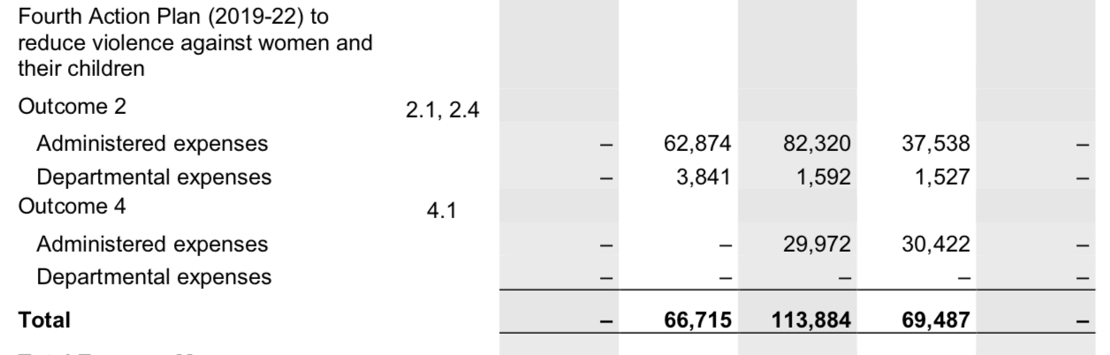

The Department of Social Services is mainly responsible for the implementation of the Fourth Action Plan.[23] Some of the measures have been described in the Cross portfolio measures in this document above. Other specific to DSS measures include:

* $0.5 million to develop a university module to train university students in key disciplines, such as health, education and training, and social work, to better recognise and respond to domestic, family and sexual violence.
* $4.5 million to establish accredited training across the community to improve worker responses to victims of sexual violence, focusing on specific forms of sexual violence, including technology-facilitated sexual violence, non-consensual image-based abuse and stalking, and on the most vulnerable cohorts including young people and women with disability.
* $0.5 million to map gaps in relation to LGBTIQ communities. This will include mapping of existing services and a round table.

## Measures indirectly related to addressing violence against women and their children

### Expansion of cashless debit cards trials

The Government proposed an expansion of the Cashless Debit Card (CDC) trial until 2021 with the total budget of $128.8 million.[24] While indicating that this is the extension of the trial until 30 June 2021, the investment is intended over 4 years.[25]

AWAVA strongly opposes the CDC trial and calls on the government to completely abandon the program. There is no evidence to suggest any positive outcomes from the compulsory punitive welfare policies. The Auditor General concluded that in the absence of effective evaluation and monitoring mechanism, it is difficult to conclude whether any positive impacts or reduction of social harm has occurred.[26] We called on the government to ensure that every member of the community is treated equally and with the dignity and respect that they deserve.

### Establishing the National Centre for the Prevention of Child Sexual Abuse

$25.5 million over six years from 2019-20 (including $4.4 million in 2023-24 and in 2024-25) will be provided to establish an independent National Centre for the Prevention of Child Sexual Abuse (the Centre) to reduce stigma, raise awareness, and prevent child sexual abuse. The Centre will commence operation in 2020-21.

# Prime Minister and Cabinet

## Measures directly related to addressing violence against women and their children

### Funding to address financial abuse

The Office for Women has been allocated additional $2million to support the development of strategies for the prevention of financial abuse. This will include evaluation of the effectiveness of existing initiatives as well as a web-training for financial services providers.

### Funding to Family Violence Prevention Legal Services

The Prime Minister and Cabinet is responsible for funding Family Violence Prevention Legal Services. Despite the calls from the service, no additional funding has been allocated.

### Funding to the National Women’s Alliances

The Office for Women has committed to providing funding of $281,000 in both the 2018-19 and 2019-20 years for each of the six National Women’s Alliances, including AWAVA.

CPI increases have not been accounted for in the funding of the National Women’s Alliances, resulting in a cut in real terms of approximately $29,000 per Alliance over the four years from July 2016 to June 2020 (assuming a CPI of 2.5%pa). This limits the ability of National Women’s Alliances to provide input to government on behalf of the diverse range of women and women’s organisations, and to represent this diversity in decision making and policy outcomes.

## Measures indirectly related to addressing violence against women and their children

### The Workplace Gender Equality Agency (WGEA)

There has been an increase in the funding to the Workplace Gender Equality Agency (WGEA). According to the Workplace Gender Equality Act 2012 (the Act) WGEA is charged with promoting and improving gender equality in Australian workplaces. WGEA annually collects data against standardised gender equality indications (GEIs):

* GEI 1: gender composition of the workforce
* GEI 2: gender composition of governing bodies
* GEI 3: equal remuneration between women and men
* GEI 4: availability and utility of employment terms, conditions and practices relating to flexible working arrangements for employees and to working arrangements supporting employees with family or caring responsibilities
* GEI 5: consultation with employees on issues concerning gender equality in the workplace
* GEI 6: sex-based harassment and discrimination.

The allocated funding is as follows:

|  |  |  |  |  |  |
| --- | --- | --- | --- | --- | --- |
|  | Millions | 2017-18 | 2018-19 | 2019-20 | 2020-21 |
| WGEA | **B. 2019-20** | 6.305 | 6.284 | 9.611 |  |

*The Prime Minister and Cabinet, p. 300*

There are no forward estimates for this measure.

# Department of Communications and Arts Portfolio

## Measures directly related to addressing violence against women and their children

### Addressing technology-facilitated violence – Additional funding to the eSafety Commissioner

In the 2018-2019 Budget the Office of the eSafety Commissioner has been allocated $14.2 million over 4 years. This included administering a new civil penalties regime to respond to the non-consensual sharing of intimate images and provide guidance and support to all people of all ages in Australia who experience online abuse.

The 2019-2020 Budget provides further $4.0 million for the Australian Communications Media Authority to identify, report and support victims of technology facilitated abuse in high-risk Aboriginal and Torres Strait Islander communities ($2.5 million) and women who have intellectual disabilities ($1.5 million). This is a part of the $328 million package.

## Measures indirectly related to addressing violence against women and their children

### Online Safety Grants Program

|  |  |  |  |  |  |
| --- | --- | --- | --- | --- | --- |
|  | Millions | 2018-19 | 2019-20 | 2020-21 | 2022-23 |
| Australian Communications and Media Authority | **B. 2019-20** | - | 2.5 | 2.5 | 2.5 |

Additional funding **($10 million**) to the Office of the eSafety Commissioner to establish a new Online Safety Grants program to support the delivery of online safety education and training projects for children. We welcome this measure and call for the Office to ensure that gender analysis is embedded within the grants guidelines. Online abuse has a strong gendered aspect to it regardless of the age. Development of this grants program should factor gender analysis in from early on.

This measure was announced in February 2019.[27]

1. AWAVA (2018) Position paper on the development of the Fourth Action Plan of the National Plan to Reduce Violence Against Women and their Children <https://awava.org.au/2018/10/08/uncategorized/position-paper-fourth-action-plan?doing_wp_cron=1554265010.0306921005249023437500>
2. ABS, 2016
3. <https://www.ourwatch.org.au/What-We-Do/Counting-on-change-A-guide-to-prevention-monitorin>
4. National Advocacy Group on Women on Temporary Visas Experiencing Violence (2018), ‘Path to Nowhere’ report <https://awava.org.au/2018/12/11/research-and-reports/path-to-nowhere-report-women-on-temporary-visas-experiencing-violence-and-their-children?doing_wp_cron=1555039382.2883679866790771484375>
5. Family Violence Prevention Legal Services, Media Release 2 April 2019 <http://www.nationalfvpls.org/images/files/20190402_National_FVPLS_Federal_Budget_2019-20_MR.pdf>
6. Commonwealth of Australia 2018 Women’s Economic Security Statement 2018 <https://www.pmc.gov.au/sites/default/files/publications/womens-economic-security-statement-2018.pdf>
7. For AWAVA’s position in relation to an early release of superannuation benefits in situations of family violence, see our submission at <https://awava.org.au/2019/02/15/submissions/submission-in-response-to-the-public-consultation-on-the-review-of-early-release-of-superannuation-benefits?doing_wp_cron=1554854017.4550290107727050781250>
8. Budget paper 2, page 173
9. Budget paper 2, p.103
10. The improvement in information sharing will also include a scoping review of technological solutions to facilitate information sharing.
11. Commonwealth of Australia (2019) Budget 2019 -2020. Building Stronger Regional Communities 2019 – 2020, pp 41-42 <https://infrastructure.gov.au/department/statements/2019_2020/ministerial-statement/files/Building-stronger-regional-communities-2019-2020.pdf>.
12. For more details see AGD media release from Dec 18 2018 <https://www.attorneygeneral.gov.au/Media/Pages/Additional-funding-for-Family-Violence-support-services-18-december-2018.aspx>
13. Commonwealth of Australia (2019) Budget 2019 -2020. Building Stronger Regional Communities 2019 – 2020, p. 42 <https://infrastructure.gov.au/department/statements/2019_2020/ministerial-statement/files/Building-stronger-regional-communities-2019-2020.pdf>
14. <https://www.ag.gov.au/FamiliesAndMarriage/Families/Pages/supporting-women-to-recover-financially-after-separation.aspx>
15. Ibid, p. 43
16. <https://www.ag.gov.au/LegalSystem/Legalaidprogrammes/Pages/Specialist-domestic-violence-assistance.aspx>
17. National Association of Community Legal Centres, Media Releaser 3rd April 2019 <http://www.naclc.org.au/resources/190403%20NACLCFederalBudgetMediaReleaseFinal.pdf?fbclid=IwAR14z2lKlMhZDLi4qIEw1iLv0n3UY-MJOMipNMHTOyKvZtnW3ACCdWnVNBo>
18. <https://www.budget.gov.au/2019-20/content/download/essentials.pdf>
19. Attorney General’s Portfolio statement, 2019-2020 Budget, p. 134.
20. Available at <http://www.fedcourt.gov.au/about/corporate-information/corporate-plan/corporate-services>
21. <https://www.aph.gov.au/Parliamentary_Business/Bills_LEGislation/Bills_Search_Results/Result?bId=r6167>
22. Women’s Legal Services Australia Media release 23 August 2018 <http://www.wlsa.org.au/media_releases/specialisation_in_family_law_integral_to_women_and_childrens_safety_-_23_august_2018> and 10 September 2018 <http://www.wlsa.org.au/media_releases/wlsa_urges_government_to_extend_reporting_period_before_dismantling_family_court> ; Law Council of Australia Media Release 13 December 2018 <https://www.lawcouncil.asn.au/media/news/proposed-merger-of-the-family-court-of-australia-and-federal-circuit-court>
23. DSS factsheet on the Fourth Action Plan <https://www.dss.gov.au/sites/default/files/documents/04_2019/pbs-fact-sheet-fourth-action-planifwi89m.pdf>
24. Department of Social Service Portfolio Budget Statement p 16, Budget Paper 2 p. 157-158.
25. <https://ministers.dss.gov.au/media-releases/4736>
26. Auditor-General Report No.1 2018–1 The Implementation and Performance of the Cashless Debit Card Trial
27. <https://www.communications.gov.au/departmental-news/keeping-our-kids-safe-online>